USER GUIDE

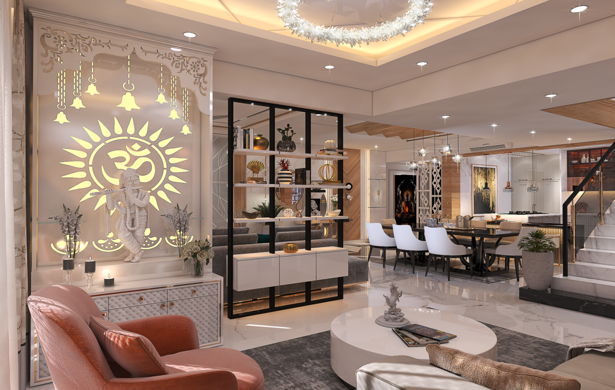

1. About Home Interior:

Welcome to our Home Interior website, Home Interior design involves planning and designing the interior spaces of a home to create a functional and comfortable pleasing environment. Choose furniture that suits the styles and scales of the room. Consider the purpose of the each space and select pieces that are both functional and select pieces that are both functional and visually appealing. Ensure that there is enough space for movement around the furniture. Select a color scheme that reflects your personal styles and complements the function of the room. Proper lightning is the crucial in creating the ambiance and highlighting design element. Incorporate a mix of ambient, task, and accent lighting for functionality and mood. A variety of textures and patterns to add depth and visual interest to the space. Mix different materials like wood, metals, fabric and glass to create a layered and inviting atmosphere. Personalize your space with accessories and decor items that reflect your personality and style. Artwork, rugs, pillows and plants can enhance the overall look of the room and add characters. We can define styles or themes for your home interior, whether its modern, tradional, eclectic or minimalist. Consistency in styling will create a cohensive look throughout the space. And now you can Join us in revolutionizing interior management – where aesthetic meets technology. Elevate your salon experience with us!

1. User Sitemap:

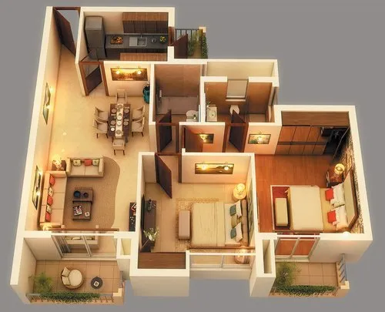

Home Page

1.Header:

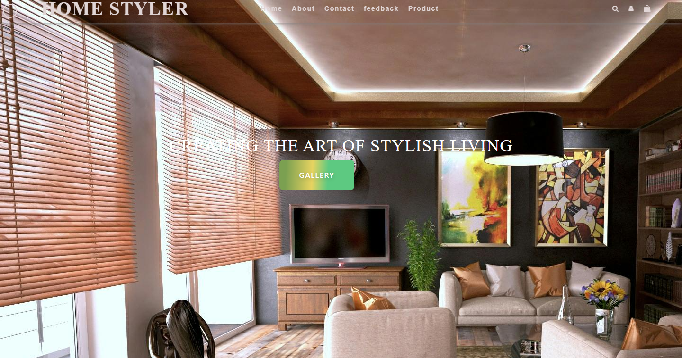

2.Interior Stylist:

In this section user can see salon stylists with Time and Shift.

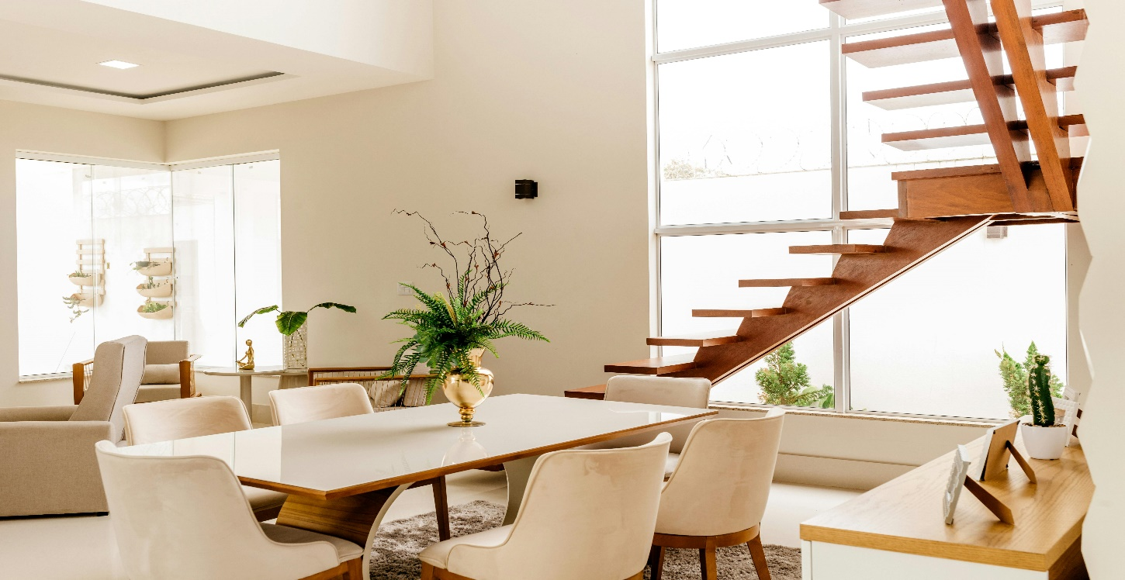

3.Interior Receptionists:

In this section user can see Salon Receptionists.



4.Book Appointment:

Then this section user can easily book appointment for click the **Appointment Now** button and they reach appointment page and book appointment.



5.Appointment Page:

In this page user can easily book appointment and click **Make an Appointment** button and then your appointment is booked.

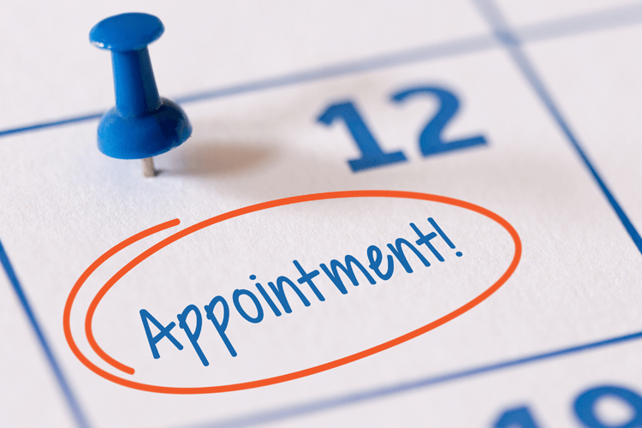

6.Checkout Page:

Then user can click checkout button and place/confirm your appointment.

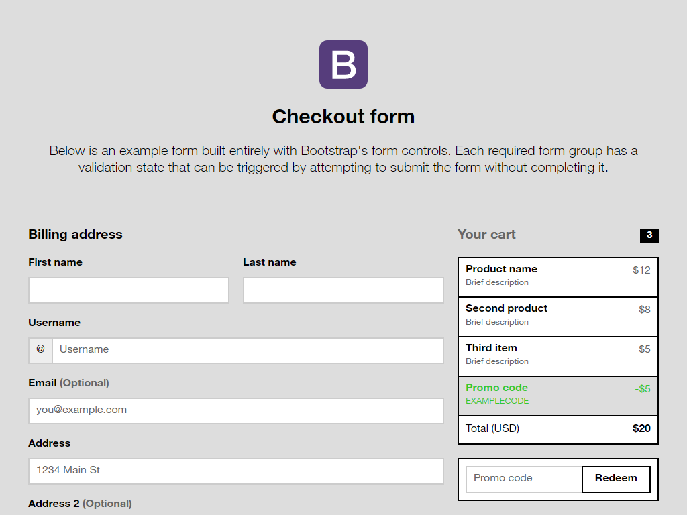

7.Appointment Search Results:

User can click search bar in **user dashboard** so they can see search your results that appointment is pending or approved.

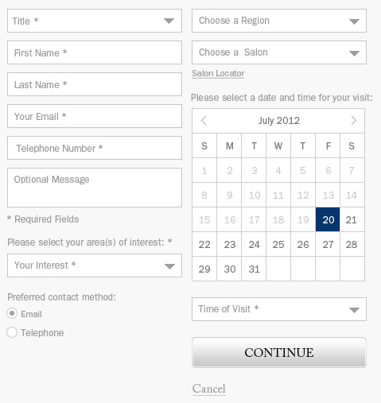

[This Photo](http://drupal.stackexchange.com/questions/115704/schedule-appointment-form-in-popup) by Unknown Author is licensed under [CC BY-SA](https://creativecommons.org/licenses/by-sa/3.0/)

**User Dashboard**



About Us Page

In this page user can give us many informations like Interior messages to customer feedback and salon specialists are available.

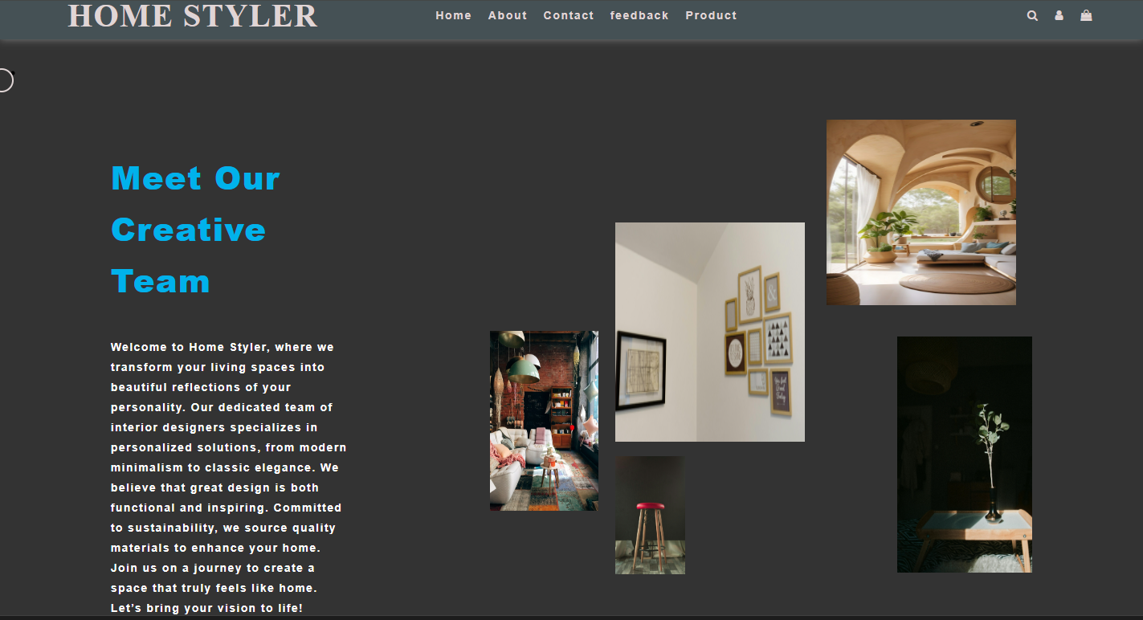

8.Blogs:

In this section user can see blogs and user can click read more button so user can see blogs details.

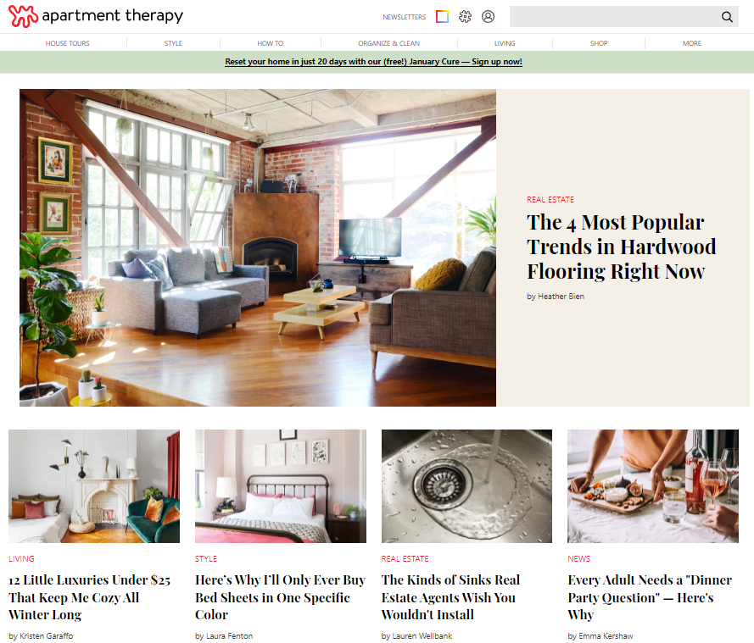

9.Blog Details:

In this section user can see blog details.

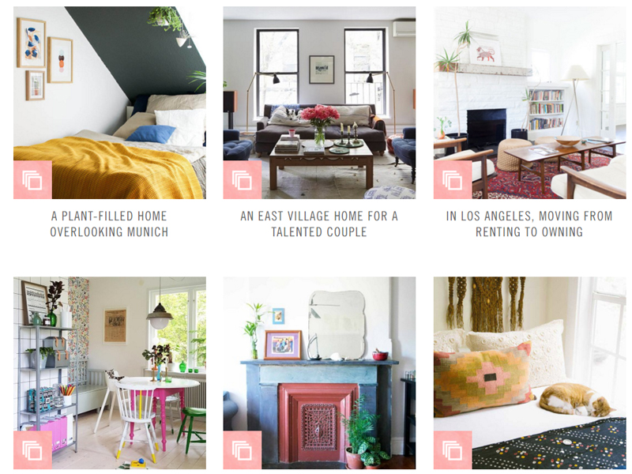

.

10.Services page:

In this page user can see different services and choose services and book an appointment.

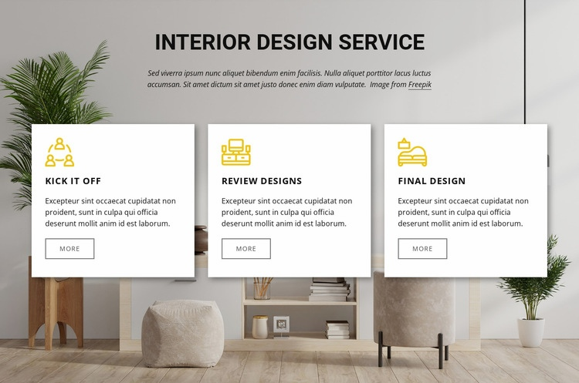

Feedback Page

In this page customer add a review and description about website.

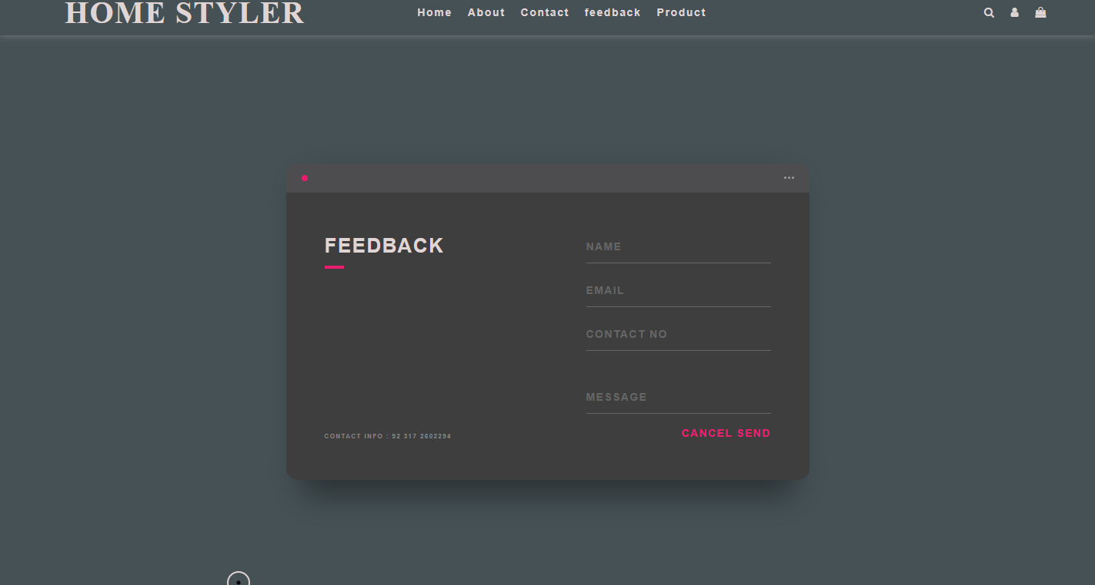

Customer Reviews

In this section user can easily see customer reviews about salon management website.

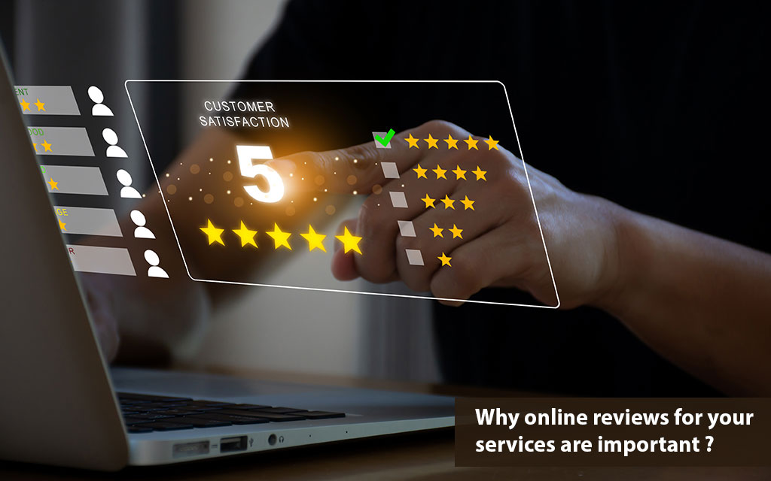

Product Description

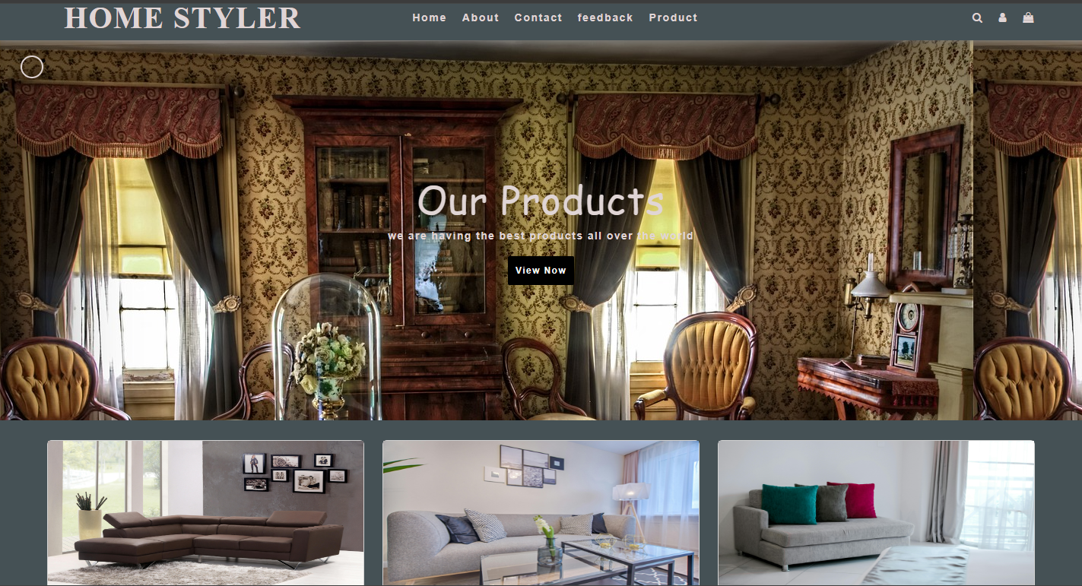

Contact Us Page

In this page user can easily contact with us.

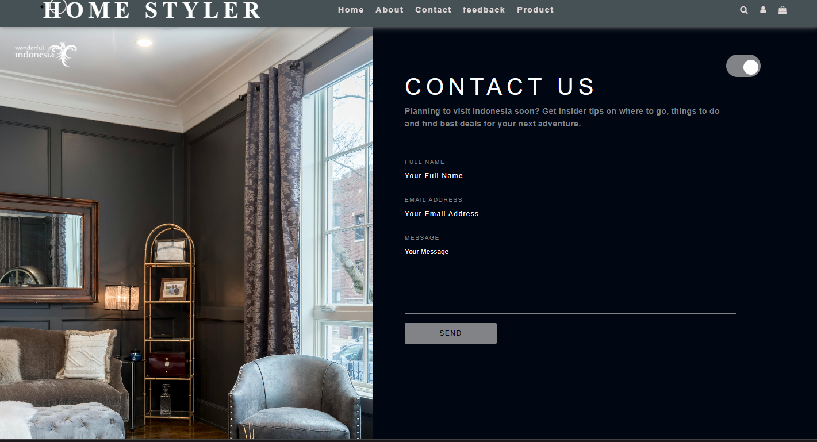

Dashboard

In this dashboard only admin can see all works and handle the website like export into excel file, add, fetch, delete, update and also included logout function.

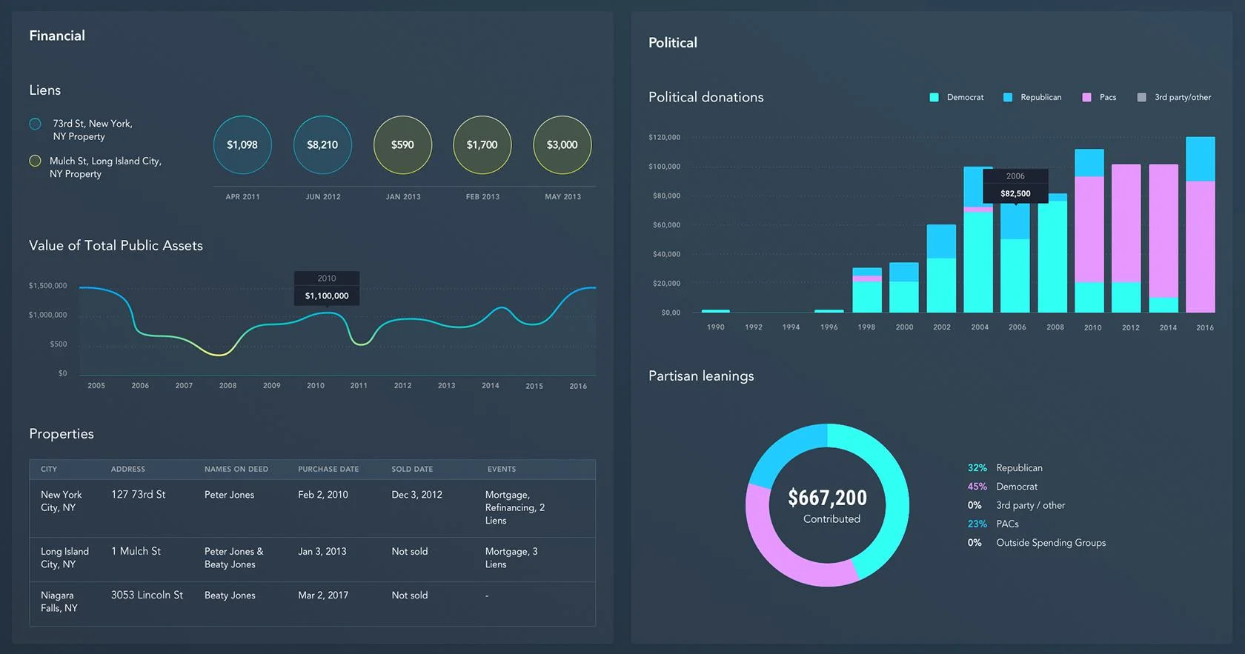

[This Photo](https://academy.hsoub.com/design/general/%D8%A3%D9%81%D8%B6%D9%84-%D8%A7%D9%84%D9%85%D8%A8%D8%A7%D8%AF%D8%A6-%D9%88%D8%A7%D9%84%D8%AA%D8%B7%D8%A8%D9%8A%D9%82%D8%A7%D8%AA-%D9%84%D8%AA%D8%B5%D9%85%D9%8A%D9%85-%D9%84%D9%88%D8%AD%D8%A7%D8%AA-%D8%A7%D9%84%D8%AA%D8%AD%D9%83%D9%85-dashboard-design-r577/) by Unknown Author is license

Stylist Dashboard

In this dashboard stylist login in website with credentials and view

Appointment record and stylist salary.

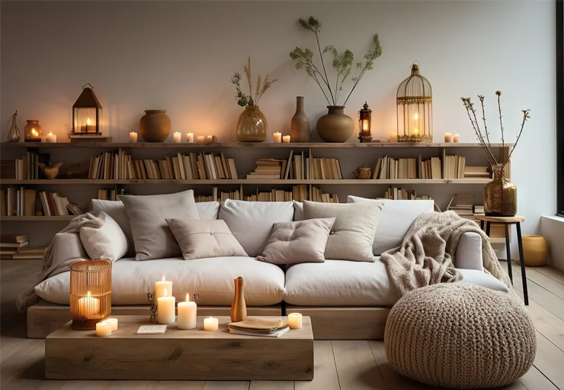

Reception Dashboard

In this dashboard receptionist login in website with credentials and view product, add product, view reception salary, appointment and delete product.

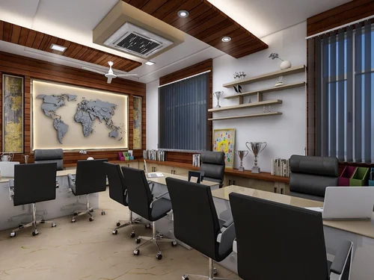

User Dashboard

In this dashboard user can see appointment data, checkout data, contact data and feedback data.

